Meeting Report 2

**Meeting one**

**10/1/2021**

**Start 9:05 AM**

**End 10:05 AM**

Our project topic is research and learns where solar panel installation on Gallaudet campus

Dylan: Find solar things that are able to collect electricity from the sun.

Mbisana/Elina: Look at the Gallaudet map to find the best place for solar panel installation, use <https://crowdai.com/> tools. (Tried to sign up but Im not authorized to log in)

Larry/David: Collect data and calculate. Maybe find tools on how to convert data.

Schedule plan:

October 4 week:

Dylan: Find tools for solar panel installation and learn how to use it.

Maybe start with an idea for a website or app, how we will set up information?

Larry: Research on how to analyze data related to Solar Panel: example:(<https://www.pveducation.org/pvcdrom/properties-of-sunlight/analysis-of-solar-irradiance-data-sets>).

<https://www.homerenergy.com/products/pro/docs/latest/generating_synthetic_solar_data.html>

<https://ourworldindata.org/grapher/annual-percentage-change-solar>

David: data percent

<https://news.energysage.com/what-are-the-most-efficient-solar-panels-on-the-market/>

<https://www.energy.gov/eere/solar/solar-energy-united-states>

Mbisana: Research and google which location and positionings are better for solar panel

<https://www.proquest.com/docview/2392860678/fulltextPDF/6C9377C598BB437FPQ/1?accountid=27346>

<https://wrlc-gal.primo.exlibrisgroup.com/permalink/01WRLC_GAL/92f5m8/cdi_crossref_primary_10_1553_giscience2015s147>

<https://www.solarpowerworldonline.com/2020/07/using-data-collection-keeps-solar-projects-running-at-full-capacity/>

**Our work here:**

Dylan: Dr. Solomon found this [Amazon solar](https://www.amazon.com/Digital-Illuminance-Handheld-Luxmeter-Backlight/dp/B07RK932TB/ref=asc_df_B07RK932TB/?tag=hyprod-20&linkCode=df0&hvadid=459726089002&hvpos=&hvnetw=g&hvrand=12903803065428492552&hvpone=&hvptwo=&hvqmt=&hvdev=c&hvdvcmdl=&hvlocint=&hvlocphy=9007531&hvtargid=pla-943927419723&psc=1) is a Light Meter Digital Illuminance Meter Measure.

It shows how powerful light is. It seems required for us to hold it to be able to get a solar energy measure of light. If we use this tool then it will have Lux as measurement but we need watts for our data so use the equation:

(multiply lux to 0.0079 which give you value of w/m2).

Lux * 0.0079 = w/m2 (99.5 * 0.0079 = 0.78605)

Overall sunlight will give more than 30,000 lux. (30,000 * 0.0079 = 237)

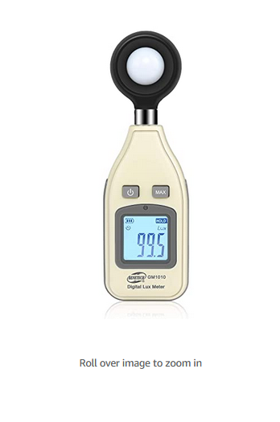

[Small piece solar panel](https://www.amazon.com/Renogy-Small-Tilt-Mount-Panels/dp/B01JQWM744/ref=sr_1_1?crid=22SHWVA0PMODR&dchild=1&keywords=solar+panels&nav_sdd=aps&qid=1633192249&refinements=p_36%3A2661612011&rnid=2661611011&s=lawn-garden&sprefix=solar+panel&sr=1-1) has solar panel sensor with two-wire plugs that can connect to the controller to see how many watts.

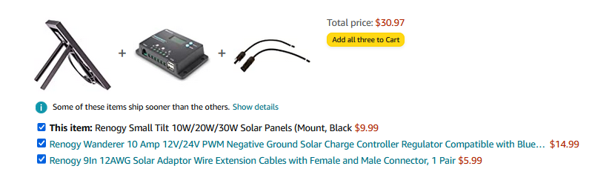

Explain how solar panels convert to energy:

* Panel build layer of silicon cells, a metal frame, a glass casing, and wiring. Solar cells (photovoltaic cells) absorb daylight.
* “..solar cell is a thin semiconductor wafer made from two layers of silicon.” One layer is positively charged and the other is negative that makes electricity. Sunlight to that cell will generate energy to create electrons that make a motion that will make the electrical current.
* Now sunlight to electricity generates two ways, direct current (DC) and alternating current (AC). There is a gadget that allows change from DC to AC called an inverter.
* Now electricity will power your home appliances.
* The electric meters collect energy to store and provide when house electricity is used.

*Solar 101: How solar energy works (step by step)*. CertainTeed. (2020, August 3). Retrieved October 8, 2021, from https://www.certainteed.com/solar/solar-101-abcs-solar-power/.

Larry: Research on how to analyze data updates. Trying to find how they found data for solar panels. I need more information to find how researchers are using their real time data.

Website that could be used:

<http://blizzard.cs.uwaterloo.ca/iss4e/wp-content/uploads/2013/03/Solar-Data-Analysis.pdf>

<https://pdxscholar.library.pdx.edu/cgi/viewcontent.cgi?article=2077&context=open_access_etds>

<https://proxyga.wrlc.org/login?url=https://www.proquest.com/scholarly-journals/optimal-tilt-angle-determination-pv-panels-using/docview/2430609011/se-2?accountid=27346>

<https://kcsolar.net/2020/11/5-popular-solar-panel-monitoring-apps-to-check-out/>

The resources I found that could be used to analyze the data. For example: They found many different ways to do data analysis by angles, months, and many more.

David:

Gallaudet university has different locations. how many percent to use it.

Buildings: Student Academic Center,(SAC),Sorenson Language and Communication Center(SLCC), Ely Center, Field House, Gallaudet University Elstad Auditorium, Gallaudet Hearing and Speech Center, Peet hall, Benson Hall, Clerc Hall, Carlin Hall Ballard North and West Hall, and Washburn Arts Center.

The schedule put down data percent. The solar panel rating measures how well the panel converts sunlight into energy. Most solar panels are using about 18-20% efficiency.

Link: <https://www.saveonenergy.com/solar-energy/most-efficient-solar-panels/>

Elina:

Monocrystalline Solar panels vs Polycrystalline Solar panels. Which one fits better for university

**\*Black ones (monocrystalline solar panels)**

**Pros:**

-Latest technology

-Eye pleasing

-More efficient (20% than blue panels)

Longer warranties

**Cons:**

-More expensive (budget??)

-Less eco friendly

-More heat, slightly reducing efficiency in hot climates

**\*Blue ones (polycrystalline solar panels)**

**Pros:**

-More affordable

-less waste created and energy used in manufacturing

-may be better in really hot sunny climates

**Cons:**

-Less efficient than black (15-17%)

-HOA requirement?

<https://news.energysage.com/why-are-solar-panels-blue/>

<https://www.solarsam.com/solar-news/black-or-blue-monocrystalline-solar-panels-vs-polycrystalline-solar-panels/>

Mbisana:

**Areas to consider install solar panels**

Olmsted Green

Hanson Plaza

Area between the SAC, Library, Peet Hall…

**Notes: the above areas have more space for solar panels installation as there is more sunlight exposure the whole day however there would be a need of metal pillars to make a tant that will hold the solar panel higher. So installing it on buildings would be better to reduce the cost of materials needed.**

**Buildings to consider**

SAC

Ely Center

Field House

Gallaudet University Elstad Auditorium

Gallaudet Hearing and Speech Center

Peet hall

Benson Hall

Clerc Hall

Carlin Hall

Ballard North and West Hall

Washburn Arts Center

**Note: the above building has more space on top for solar panel installation however there are factors that might affect solar panels which should be taken into account before installation.**

**Factors to consider before installing solar panel**

<https://www.proquest.com/docview/2392860678/fulltextPDF/6C9377C598BB437FPQ/1?accountid=27346>

<https://wrlc-gal.primo.exlibrisgroup.com/permalink/01WRLC_GAL/92f5m8/cdi_crossref_primary_10_1553_giscience2015s147>

**Dusting:** things like bird droppings, pollution and dust can affect and reduce the performance of solar panels as they cover and prevent the sunlight from hitting the solar panel. So the user has to make sure to clean it everyday for it to function properly. Or it is better to find a place away from the dustings before installation.

**Shading:** Shadings like Building and tree shadow can affect the entire solar panel because there is a current flowing around the string that transmits power whereas if even a single string has shading it will affect the entire solar panel and result in power loss output.

**Weather:** solar panels work best in full direct sunlight if the weather is cloudy and raining that will affect its output so it is better to select modern solar panels which are designed to thoroughly penetrate the bad weather.

**Position/location (direction toward the sunlight):** solar panels generate more electricity when they are closer to the sun so since the sun passes through the equator, it means the closer the solar panel is to the equator the more power absorbed. Whereas if we are in the northern hemisphere our solar panel should face south to the equator.

**Next plan:** Ask permission to access and observe all the building to see if they are suitable for solar panel installation, results due: Friday 15th

Links:

<https://www.scientificamerican.com/article/science-with-a-smartphone-measure-light-with-lux/>

<https://crowdai.com/>

**Meeting two**

**10/10/2021**

**Start 10:10 AM**

**End : 11:30 AM**

Dylan, Mbisana, Elina, David, Larry

Plan during the meeting: We are working on more research and discuss on our work and idea for questions to ask David Goods who comes to class onOct 11, 2021.

Our plan for this week and next week:

Hopefully, get solar equipment soon to start experimenting with it.

Order Solar panel first thing tomorrow morning during class. (I think we could go with the Lux first one) We have to carry it.

Once we get the equipment we will need to discuss a specific location where we should test.

Dylan: Read more on the article or website about how electricity works from solar panels.

Get equipment so able to walk the campus to get data.

Larry: I found an article that is very helpful with our research:

<https://proxyga.wrlc.org/login?url=https://www.proquest.com/scholarly-journals/optimal-tilt-angle-determination-pv-panels-using/docview/2430609011/se-2?accountid=27346>

* This article shows what resources we can use and which angles that benefit our campus.
* Resources that they are using technology.
* Experiment on which specific months they are using with solar panels

Develop questions for David Good:

Does Gallaudet have solar panels around campus?

Does Gallaudet have any tools that convert solar energy to watts data?

Did Gallaudet ever plan or think about installing solar panels around campus?

What challenges do you think Gallaudet might face while installing solar panels?

Why not Gallaudet installation solar panel when it becomes well aware?

Where do you think is the best place to install solar panels around the Gallaudet campus?

Do you think which is the best option to install in a few main buildings or spread all-around buildings on campus?

Who should we contact for permission access to the building?